Service description

The threshold-based maintenance triggering service is designed to monitor the health status of SEW production modules every *n* days and give inspection and replacement suggestions for the sub elements that compose a certain module (for more contextual details please refer to Deliverable 5.2). For further versions, this service could be automated to run periodically and provide maintenance recommendations when needed. In the current version, the service is launched manually by the maintenance manager every n days to retrieve maintenance suggestions.

Inputs

The service requires two inputs:

* The module ID (appellation) for which the manager wishes to check the health status and/or receive maintenance suggestions. This is a user-defined input.
* A CSV file containing failure and maintenance data for lines, modules, and sub-elements. This file is maintained and updated by maintenance operators following the format provided below.

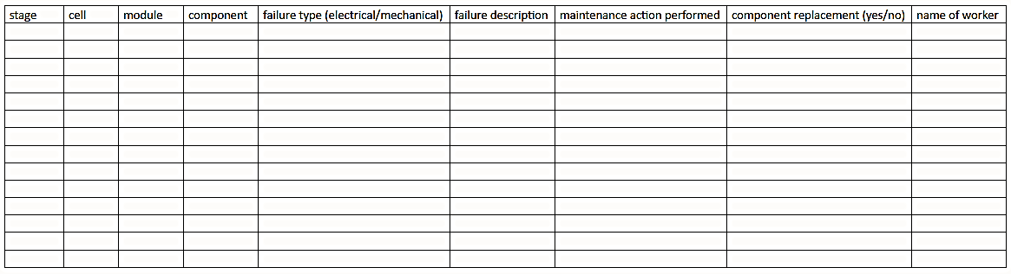

Note: this format provided by Olivier is lacking the date stamp of the event.

In this version, the module ID and sub-element IDs are predefined as internal parameters, since the approach has only been tuned and implemented for the “Press” module, due to data availability. This means that only the second input (the CSV file) is currently required. Future versions may incorporate the module ID as a user input, allowing the algorithm to dynamically determine the relevant sub-elements based on a predefined hierarchical dictionary of SEW components.

The input CSV file should contain the following data types: all columns are of type str. The 'module' and 'component' columns store the IDs of the corresponding module and component; these can be either str or int.

Output

The output of the algorithm is a str statement containing:

* Maintenance actions to be scheduled
* Contextual information about the maintenance recommendation

Such output should then be converted to notifications, which can be used to schedule maintenance actions and to update production schedules accordingly.

Tests

The algorithm is currently working with an adapted version of the database provided by SEW, renamed here as “CORIM_tool_test.CSV”.

* To simulate replacement suggestions, please set the parameter replacement_threshold = 8 and today = pd.to_datetime("21/08/2024", dayfirst=True).
* To simulate an inspection suggestion, please set replacement_threshold = 7 and today = pd.to_datetime("21/08/2024", dayfirst=True)